Start up procedures for Eflex.

Start up is crucial 

1. Verify incoming voltage. Verify incoming voltage is balanced (see IOM), Check phase monitor.
2. Verify economizer is pulled out and set in place (if available).
3. Verify all electrical connections are secure, (Overlook unit components after shipping).
   1. Ton Eflex.

* Verify the compressor configuration Dip switches are set properly.
  1. 3T Ultra High Efficiency Unit:



* 1. 4T Ultra High Efficiency Unit: 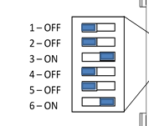
  2. 5T Ultra High Efficiency Unit: 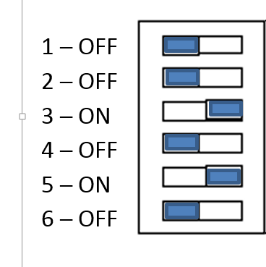

Voyager Eflex 12.5-25 Ton

Verify the compressor configuration Dip switches are set properly.

* 1. 12.5T Ultra High Efficiency Unit: 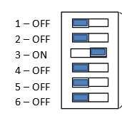
  2. 15T & 17.5T Ultra High Efficiency Units: 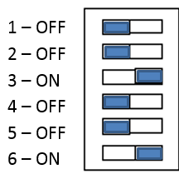

6-10 tons you are not required to set dip switches. But would recommend checking the configuration plug example from the wiring diagram. 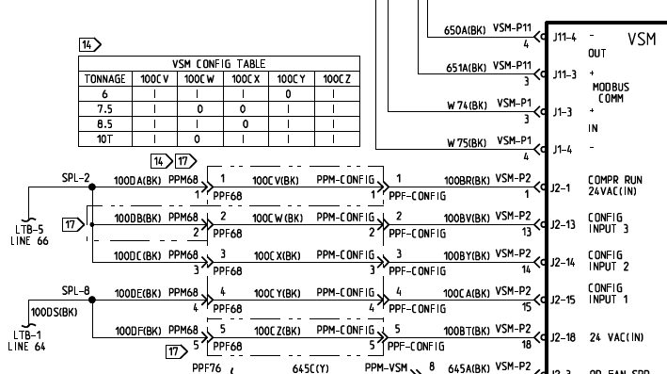

* Air Flow setup: The setup process of air flow is critical to the savings and performance of the product

 Steps:

1. Put unit in test mode heat (turn gas valve off if necessary). Take external static

Example: 3-5 ton: 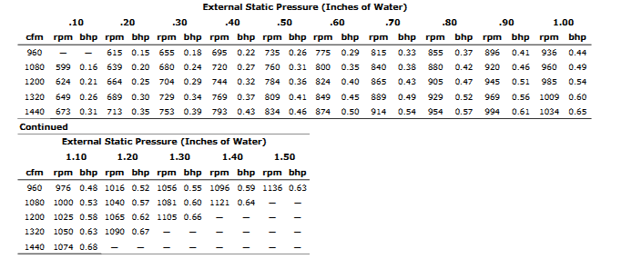 “Add supply and return” Static pressure determines the airflow. Add supply and return at start up and dial in fan speed to the design airflow.

1. Locate the rpm of indoor motor selection and dial in: See service facts for products directions for HOW TO. Precedent products rtom Potentiometer is used to set the fan speed. Voyager fan speed is set by the motor sheave. (see iom)

Example from Precedent 3-5 ton IOM.

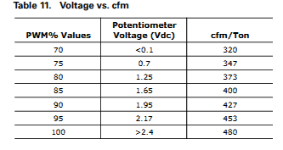

1. SZVAV discharge Temp limit user set point. Confusion between products!!!

“Precedent” new products no set point local needed “resistor installed is set for 53f

“Voyager” Turn RTOM DA cool completely counterclockwise “Voyager”

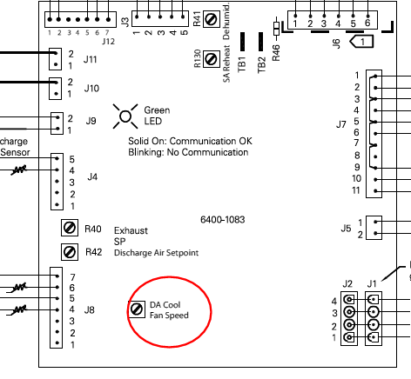

Demand Control Ventilation wiring and startup:

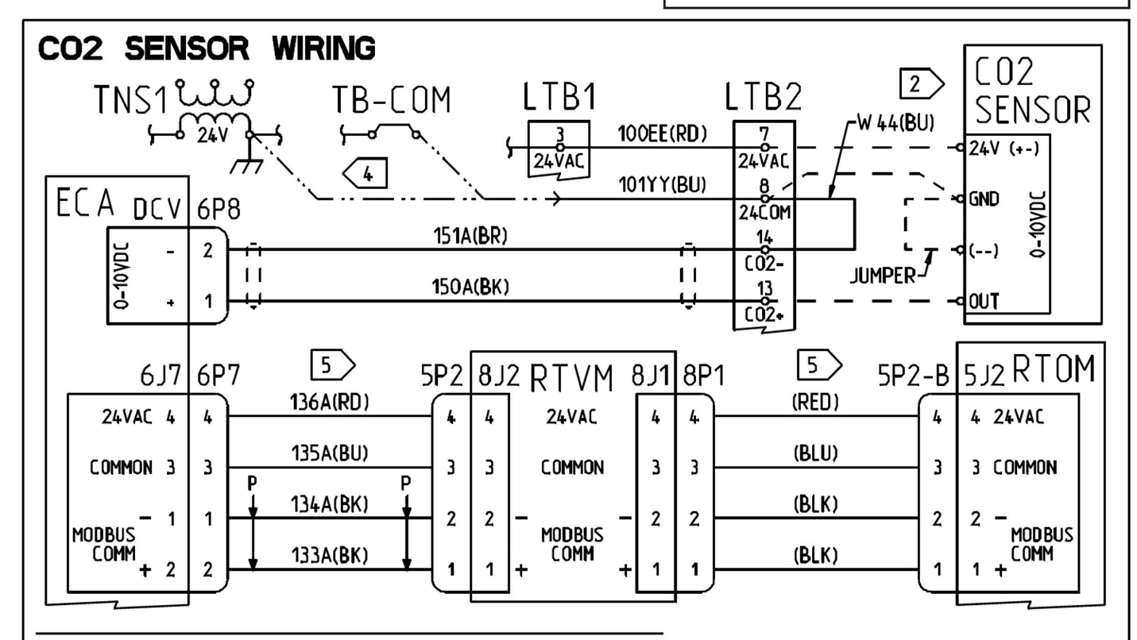

There are 3 fan speed reference points which will be referred to as Low, Medium, and High fan speeds.

The DCV set up procedure should be done in test mode.

The supply fan test (1st step in test mode) forces the supply fan in the Low fan speed.

The compressor stage 1 test (3rd step in test mode) forces the supply fan into the Medium fan speed.

The compressor stage 2 test (4th step in test mode) forces the supply fan to the High fan speed.

It is highly recommended to connect the CO2 sensor directly at the unit to LTB4 for convenience. It is much more difficult to verify set points and functionality with the CO2 sensor in the space away from the unit. Breathing on the CO2 sensor simulates a high CO2 concentration in the space.

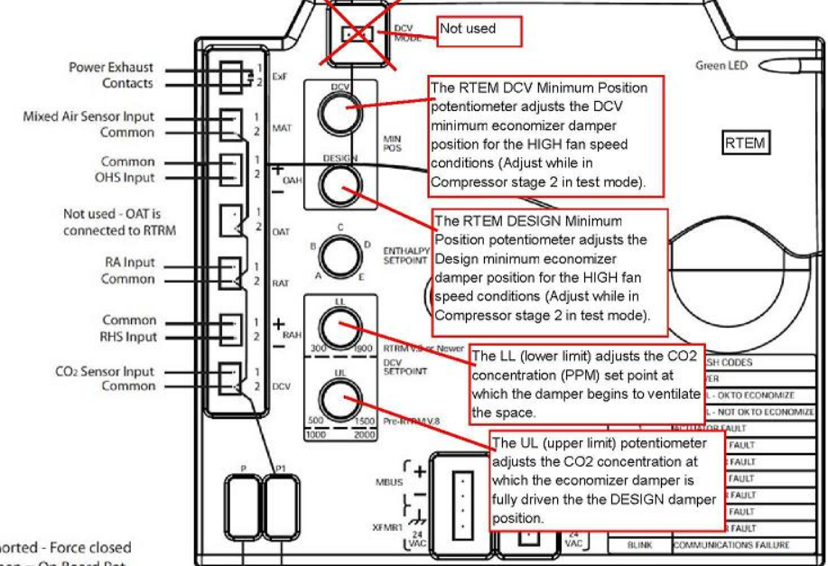

In addition to the RTEM (ReliaTel Economizer Module) a circuit board called the RTVM (ReliaTel Ventilation Module) is required for DCV operation on Light Commercial multi speed supply fan and single zone VAV units. This module is based off of the RTOM (ReliaTel Options Module) but the RTVM has different components and firmware installed. The RTVM is provided in the DCV accessory kit and is mounted next to the RTOM. See the accessory kit instructions for installation details.

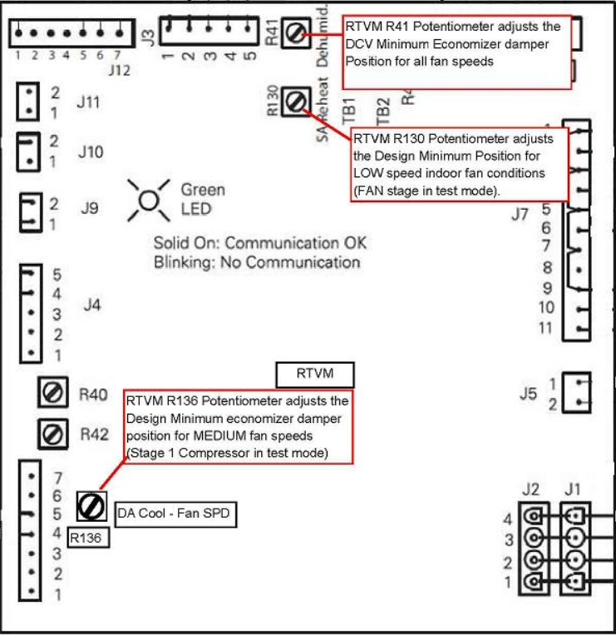

Initial set up.

For damper position adjustment, the Lower Limit (LL) CO2 PPM adjustment potentiometer should be set to the lowest position (counter clockwise) and the Upper Limit (UL) CO2 PPM adjustment potentiometer should be set to approximately half way. These can be adjusted later to the required levels.

A CO2 sensor should be wired at the unit at LTB4 for the convenience of set up.

Terminology. Design Min-is the max damper position when you have high concentration of Co2.

DCV Min- is the dampers position when fan is on without co2

All three of the Design Minimum adjustment potentiometers (R130 on the RTVM, R136 on the RTVM, and Design Min on the RTEM should be set to the maximum position (fully clockwise) and both of the DCV Minimum adjustment potentiometers (R41 of the RTVM and DCV Min of the RTEM) should be set to the minimum position as a starting position.

Set up the LOW fan speed damper positions

Enter into the test mode to the supply fan test step (1st step in test mode).

Adjust the R130 potentiometer on the RTVM to set the LOW fan speed Design minimum damper position. The Design minimum position set point controls the damper position when there is a high concentration of CO2 in the space and ventilation is required. The damper can be set from 0% open to 100% open during the LOW fan speed.

Adjust the R41 potentiometer on the RTVM to set the LOW fan speed DCV minimum position. The DCV minimum position set point controls the damper position when there is a low concentration of CO2 in the space. The damper can be set from 0% open to 100% open in the LOW fan speed.

Ensure that the R130 LOW fan speed Design minimum damper position is set greater than the LOW fan speed DCV minimum damper position.

Blow on the CO2 sensor to simulate a high concentration of CO2 to confirm the economizer damper responds to the call for ventilation.

 This Procedure must also be repeated for the MEDIUM and HIGH fan speeds

Set up the MEDIUM fan speed damper position

 Advance to the 3rd step in the test mode (1st stage compressor). This forces the supply fan to the MEDIUM fan speed. Adjust the R136 potentiometer on the RTVM to set the MEDIUM fan speed Design minimum damper position. The damper can be set from 0% open to approximately 75% open in the MEDIUM fan speed.

There is no DCV Min setup for MEDIUM fan speed. The value from R41 from the previous step is retained for the MEDIUM fan speed.

Again blow on the CO2 sensor to simulate a high concentration of CO2 to confirm the economizer damper responds to the call for ventilation.

Set up the HIGH fan speed damper positions

 Advance to the 4th step in the test mode (2nd stage compressor). This forces the supply fan to the High fan speed.

Adjust the Design Min potentiometer on the RTEM to set the HIGH fan speed Design minimum damper position. The damper can be set from 0% open to approximately 50% open in the High fan speed.

Adjust the DCV Min potentiometer on the RTEM to set the High fan speed DCV minimum position.

Again blow on the CO2 sensor to simulate a high concentration of CO2 to confirm the economizer damper responds to the call for ventilation.

After this procedure is finished adjust the Lower Limit (LL) CO2 PPM adjustment potentiometer and the Upper Limit (UL) CO2 PPM adjustment potentiometer on the

RTEM to the required settings for the application. This is often determined by local codes

**Startup of modulating gas heat Precedent 6-10 ton.**

* Use test mode to put unit in heat 2
* Check the RTOM J5 plug for 10vdc (this will be 100% heat)
* Adjust manifold at standard gas valve but check pressure at the maxitrol valve. 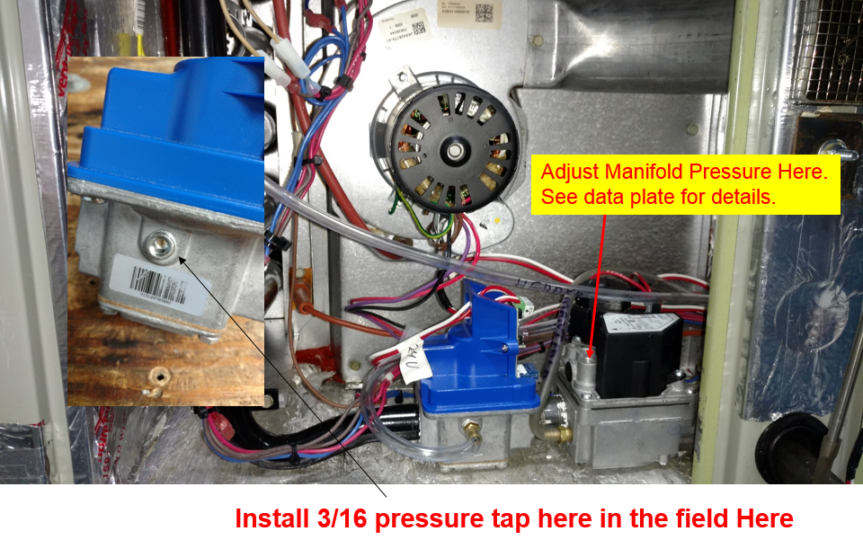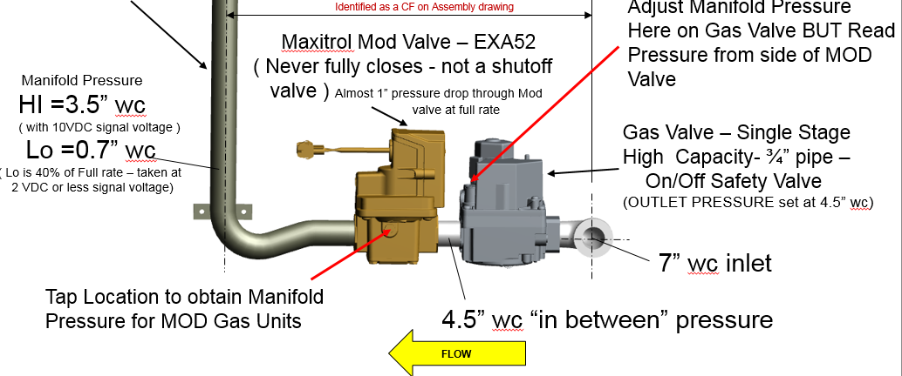

Adding a humidity sensor for enhanced dehumidification.

A humidity sensor that is capable of providing a 4-20 ma output is wired to the NLTB pins 18 &19. The setpoint is can be set at the RTOM or through a BAS system.

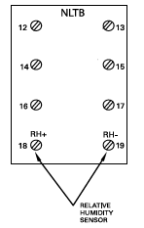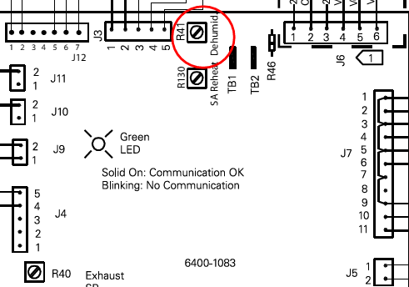

Take the Time to check unit’s Temp difference from supply and Return while in test mode full cooling.

Overlook all electrical connections. Check amp draws, and inspect system operation.